1. Provide the list of markets in which customer "Atliq Exclusive" operates its business in the APAC region.  
  
SELECT DISTINCT customer,market,region

FROM gdb023.dim_customer

WHERE customer='ATLIQ EXCLUSIVE' AND region='APAC';

OUTCOME:

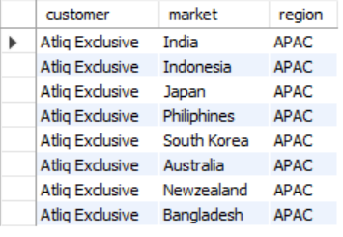

2. What is the percentage of unique product increase in 2021 vs. 2020? The final output contains these fields, unique_products_2020, unique_products_2021, percentage_chg.  
SELECT

COUNT(DISTINCT CASE WHEN fiscal_year=2020 THEN product_code end) AS unique_product_2020 ,

COUNT(DISTINCT CASE WHEN fiscal_year=2021 THEN product_code end) AS unique_product_2021 ,

ROUND((COUNT(DISTINCT CASE WHEN fiscal_year=2021 THEN product_code end)

-COUNT(DISTINCT CASE WHEN fiscal_year=2020 THEN product_code end))*100

/COUNT(DISTINCT CASE WHEN fiscal_year=2020 THEN product_code end),2)   
AS percentange_change

FROM gdb023.fact_sales_monthly;  
OUTCOME:

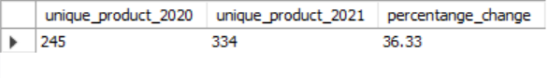

3. Provide a report with all the unique product counts for each segment and sort them in descending order of product counts. The final output contains 2 fields,  
SELECT segment,COUNT(DISTINCT product_code) AS poduct_count FROM gdb023.dim_product   
GROUP BY segment  
ORDER BY poduct_count DESC;  
OUTCOME:   
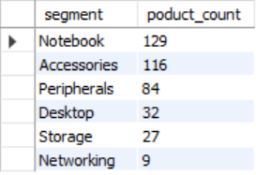

4. Which segment had the most increase in unique products in 2021 vs 2020? The final output contains these fields, segment product_count_2020, product_count_2021 difference.  
  
SELECT p.segment,

COUNT(DISTINCT CASE WHEN fiscal_year=2020 THEN p.product_code END) AS unique_product_2020,

COUNT(DISTINCT CASE WHEN fiscal_year=2021 THEN p.product_code END) AS unique_product_2021,

(COUNT(DISTINCT CASE WHEN fiscal_year=2021 THEN p.product_code END)-

COUNT(DISTINCT CASE WHEN fiscal_year=2020 THEN p.product_code END))/

COUNT(DISTINCT CASE WHEN fiscal_year=2020 THEN p.product_code END)

AS increase_percentage

FROM gdb023.dim_product p JOIN gdb023.fact_sales_monthly fs

ON p.product_code=fs.product_code

GROUP BY p.segment

ORDER BY increase_percentage DESC

LIMIT 1 ;

OUTCOME:

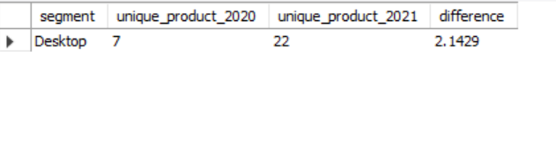

5. Get the products that have the highest and lowest manufacturing costs. The final output should contain these fields, product_code ,product ,manufacturing_cost.  
  
SELECT p.product_code,product,manufacturing_cost

FROM gdb023.fact_manufacturing_cost mc

JOIN gdb023.dim_product p

ON mc.product_code=p.product_code

WHERE manufacturing_cost= (SELECT max(manufacturing_cost)

FROM gdb023.fact_manufacturing_cost)

OR

manufacturing_cost= (SELECT min(manufacturing_cost)

FROM gdb023.fact_manufacturing_cost ) ;  
  
OUTCOME:

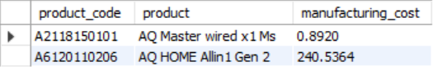

6. Generate a report which contains the top 5 customers who received an average high pre_invoice_discount_pct for the fiscal year 2021 and in the Indian market. The final output contains these fields, customer_code,   
customer average,_discount_percentage.  
   
SELECT c.customer_code,customer,pre_invoice_discount_pct

FROM gdb023.dim_customer c

JOIN gdb023.fact_pre_invoice_deductions id

ON c.customer_code= id.customer_code

WHERE market='india'AND fiscal_year=2021

HAVING pre_invoice_discount_pct >

( SELECT AVG(pre_invoice_discount_pct)

FROM gdb023.fact_pre_invoice_deductions

WHERE market='india' AND fiscal_year=2021 )

ORDER BY pre_invoice_discount_pct DESC

LIMIT 5;  
  
OUTCOME:  
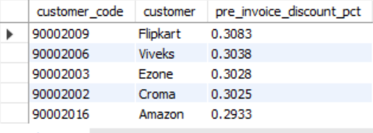

7.Get the complete report of the Gross sales amount for the customer **“Atliq Exclusive”** for each month **.** This analysis helps to get an idea of low and high-performing months and take strategic decisions. The final report contains these columns: Month Year Gross sales Amount   
  
SELECT c.customer,MONTHNAME(fs.date) month,YEAR(fs.date) year,

ROUND(SUM(sold_quantity*gross_price),-2) AS gross_total_price

FROM gdb023.fact_sales_monthly fs

LEFT JOIN gdb023.dim_customer c   
ON fs.customer_code= c.customer_code

LEFT JOIN gdb023.dim_product p   
ON fs.product_code=p.product_code

LEFT JOIN gdb023.fact_gross_price gp   
ON p.product_code=gp.product_code

WHERE customer="Atliq Exclusive"

GROUP BY year,month

ORDER BY year,month desc;

OUTCOME:  
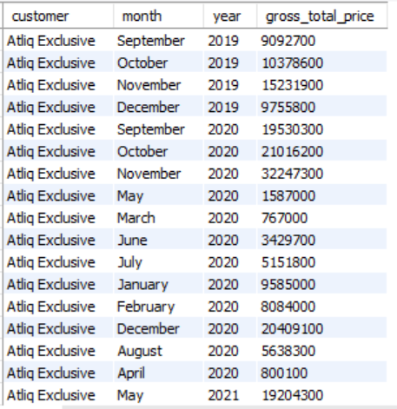

8. In which quarter of 2020, got the maximum total_sold_quantity? The final output contains these fields sorted by the total_sold_quantity, Quarter total_sold_quantity.

SELECT SUM(sold_quantity) Total_quantity ,

DATE,

CASE

WHEN MONTH(DATE) BETWEEN 9 AND 11 THEN 'Q1'

WHEN MONTH(DATE) IN (12,1,2) THEN 'Q2'

WHEN MONTH(DATE) BETWEEN 3 AND 5 THEN 'Q3'

WHEN MONTH(DATE) BETWEEN 6 AND 8 THEN 'Q4'

END AS QUARTER

FROM gdb023.fact_sales_monthly

WHERE fiscal_year=2020

GROUP BY QUARTER,DATE

ORDER BY QUARTER,DATE;

OUTCOME:

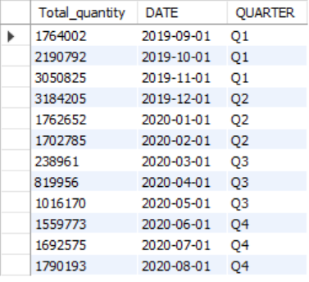

9. Which channel helped to bring more gross sales in the fiscal year 2021 and the percentage of contribution? The final output contains these fields, channel gross_sales_mln ,percentage.

WITH gross_cte AS(

SELECT c.channel,

SUM(fs.sold_quantity*gp.gross_price)

AS gross_total_price

FROM gdb023.fact_sales_monthly fs

LEFT JOIN gdb023.fact_gross_price gp on fs.product_code=gp.product_code

LEFT JOIN gdb023.dim_customer c on c.customer_code= fs.customer_code

GROUP BY c.channel

ORDER BY c.channel DESC)

SELECT channel,gross_total_price,

ROUND(gross_total_price*100/ (SELECT SUM(gross_total_price) FROM gross_cte),1)

AS percentage

FROM gross_cte

LIMIT 1 ;

OUTCOME:

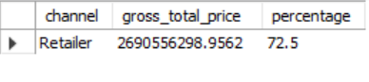

10.Get the Top 3 products in each division that have a high total_sold_quantity in the fiscal_year 2021? The final output contains these fields, division ,product_code .WITH pro_cte AS

(SELECT p.division, p.product, p.product_code, sum(s.sold_quantity) total_quantity

FROM gdb023.fact_sales_monthly s

LEFT JOIN gdb023.dim_product p ON p.product_code=s.product_code

WHERE s.fiscal_year=2021

GROUP BY p.division,p.product, p.product_code

ORDER BY p.division,p.product, p.product_code )

SELECT division, product_code, total_quantity,top3_rank

FROM ( SELECT pro_cte.*,

RANK() OVER (PARTITION BY division ORDER BY total_quantity DESC) AS top3_rank

FROM pro_cte

) ranked

WHERE top3_rank <=3;  
  
OUTCOME:

